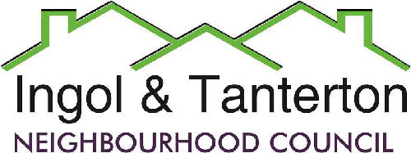
Gill Flynn- Clerk and RFO
Email: ingoltantertonnc@hotmail.co.uk

Agenda
A meeting of the Ingol and Tanterton Neighbourhood Council Area Enhancement Committee will be held on Thursday 22nd January 2026 at 6.30pm at Tanterton Village Centre.

1.To receive apologies.

2.To receive declarations of interest and dispensations.

3.To approve the minutes of the meeting held in June 2025.

4.Public participation.

5.To consider the update for the Tanterton Village Green area.

6.To consider the update for Dovedale play park.

7.To consider the review and discuss the next steps for the Tanterton side of Tag Lane from Nog Tow roundabout.

8.To consider the purchase of a noticeboard for Ingol West Ward.

Press and public are welcome to attend.

